## **To create a IAM User using Terraform**

**Step** **1 :** Mention the provider and region in which you want to create the AWS resources .

provider "aws" {  
 region = "ap-south-1"  
}

**Step 2:** Then create an IAM User for particular AWS service. Here i have created IAM User for EC2 service .

**Main.tf**

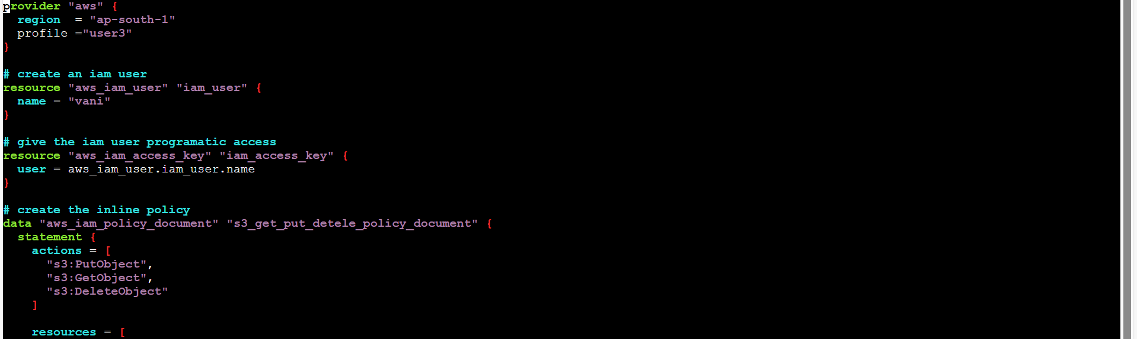

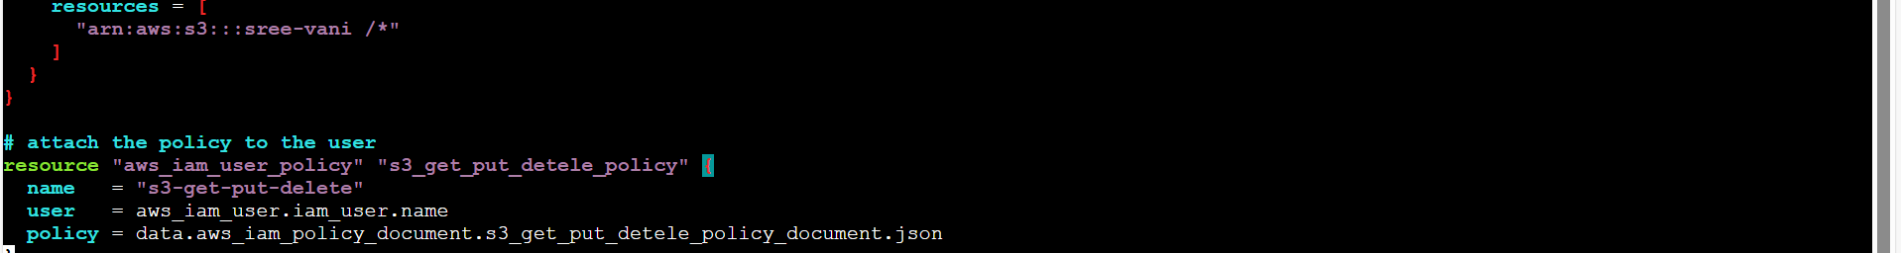

**Step 4:** Now execute the terraform file using the below commands one by one .

Terraform init

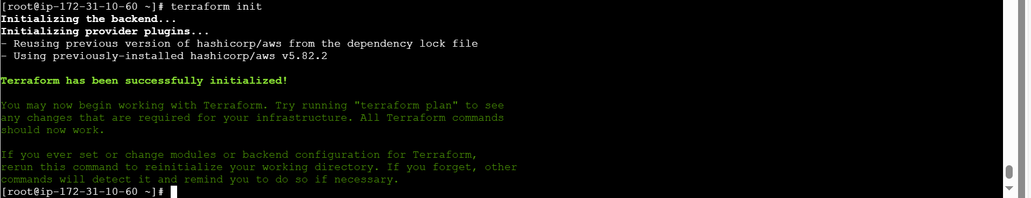

Terraform plan

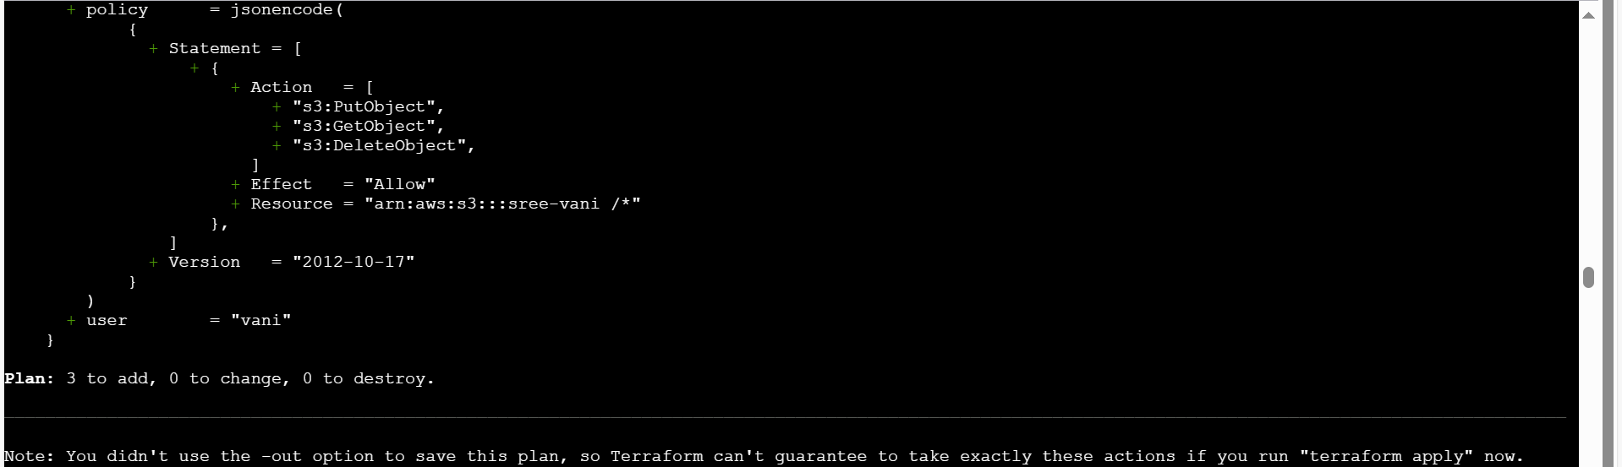Terraform apply

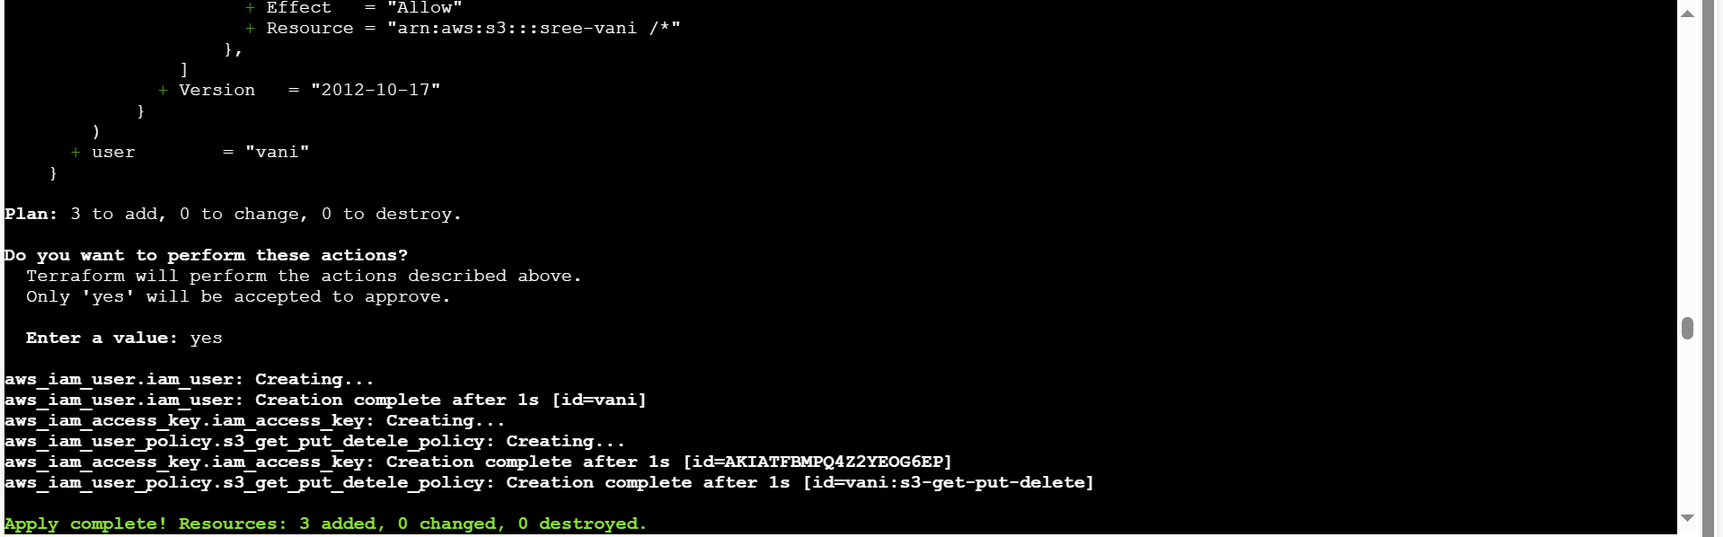

Final output:

